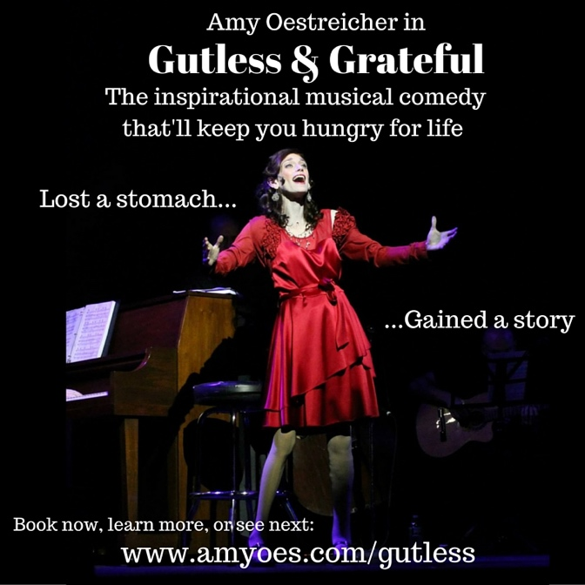
Gutless & Grateful is the one-woman musical autobiography of Amy Oestreicher, taking her audience on a journey of hope, resilience and gratitude. An inspiring story of survival and determination, Gutless & Grateful is appropriate for audiences of all ages. The 70 minute performance can be customized as an ideal event for fundraisers, support groups, hospitals, non-profit organizations, theatres, cabarets, schools, conferences, seminars, motivational speaking engagements, and special events.

Amy Oestreicher was an ambitious, audacious teenager who had her life all planned out: go to college, win a Tony, and conquer the world. But life took an unexpected detour when the week before her high school senior prom, she found herself in unusual pain. She was rushed to the emergency room, and due to a blood clot, Amy’s stomach exploded to the ceiling of the operating room. After both lungs collapsed, she almost died.

Months later, she awoke from a coma covered in tubes, bags, and drains, and was told that she had no stomach anymore, she could not eat or drink, and it was not certain if or when she would ever taste one bite ever again. It took 27 surgeries and over three years, but eventually, Amy was miraculously reconstructed, and with the intestines she had left, was given a system that digests food.

Come for an evening of inspiring story-telling and song as she shares the disappointments, the triumphs, and the humor – the challenges, the battles, and ultimately the gifts of what Amy received from this experience. It is a story of hope, determination, and perseverance a way to share her gratitude and strength with the world. Through the ups and downs, Amy’s fight proves that you never know what you are capable of until you are asked to the challenge and the human spirit can prevail over any odds.

Through seven years of surgeries and medical crises, Amy never let herself feel like a “patient” or “victim.” Rather than mourn her hunger, she started a chocolate business, a food blog, learned karate, starred in musicals, put up several art shows, and taught nursery school. Through it all, Amy has always kept her spirit alive and her appetite for life ravenous. Amy was featured on CBS and the TODAY show, where she shared her joy and gratitude for being alive, as well as her hunger for everything life can offer. With musical direction from acclaimed musical director David Brunetti and renowned composer David Friedman, the act also includes a song David Friedman wrote especially for Amy with lyrics by Kathie Lee Gifford.

With sold-out runs including Stage 72, The Bijou Theatre, United Solo Festival, Barrington Stage Company (Tony-Award winning William Finn’s Cabaret Series) and a nationwide tour, Amy Oestreicher’s hit one-woman musical Gutless & Grateful has been a critic’s darling for five years, earning BroadwayWorld Best Theatre Debut Nominee, NYC Top Bistro Pick, and Woman Around Town’s Women of the Year 2014.
“Gutless & Grateful: is not a story about a victim, but one of a survivor. Amy has channeled the pain of her experiences into something far greater.” – Michelle Alerte (Woman Around Town)
“One part moving testament to human indomitability, the other a thoroughly satisfying evening of song. While each element is strong enough to stand on its own, combined they illuminate and enhance each other. Rarely have I seen narration and song so artfully meshed, and Oestreicher’s likeability, good humor, interpretive skill, and manifest commitment to what she is saying and singing make us not only understand her story, but also feel it on a very deep level.”
-Roy Sander (critic for BistroAwards.com)
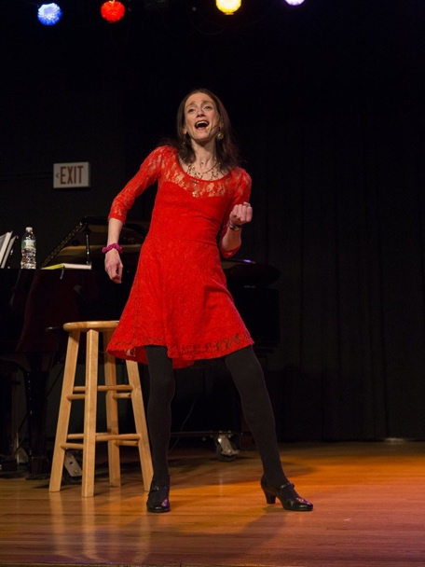
“Oestreicher’s story is always inspirational and surprisingly funny.” – Paulanne Simmons (Times Square Chronicles)
Amy Oestreicher is an artist, author, speaker for RAINN, writer for The Huffington Post, award-winning health advocate, actress and playwright, eagerly sharing the lessons learned from a decade of trauma through her writing, performance, art and speaking.
Amy’s story and show have appeared on the TODAY Show, CBS, WNBC Cosmopolitan, Seventeen Magazine, Unmistakable Creative, Good Housekeeping, among others, and her writings have appeared in over 70 notable lifestyle, wellness, and arts publications. Amy’s “beautiful detour” inspired her to create the #LoveMyDetour movement, a campaign inspiring people to flourish because of, rather than in spite of challenges.
“As a survivor and “thriver” of nearly 30 surgeries, a coma, and a decade of medical trauma, I have been challenged with moments of extreme difficulty. But as an artist, newlywed, actress, 28-year old college student and overall lover of life, I’ve learned so much from this beautiful detour. Now, my life’s’ passion share my message and tell my story, in the hope that it will inspire other people to find gratitude in the miracles of every day.” – Oestreicher
As a mental health advocacy program, “Gutless & Grateful” has toured colleges campuses nationwide, as well as reaching audiences at international conferences and festivals including for the Transformative Language Arts Network National Conference, the Eating Recovery Center Foundation, the Pacific Rim Conference on Diversity and Disability, the National Mental Health America Conference, and The League for the Advancement of New England Storytelling.
- View Amy's TEDx Talk at amyoes.com/TEDX
- Learn more about Gutless and Grateful at amyoes.com/GUTLESS
Upcoming shows:
- Metropolitan Room: February 5th, 25th
- 54 Below: June 9th
Email: amyoes70@gmail.com
Phone: 203 209 4948
Site: www.amyoes.com

Spirituality and Faith Workshops and Performances
“As the granddaughter of holocaust survivors, I relied on my grandmother’s strength and spirit in order to survive, which inspired a spirituality-fueled resilience.”

See full descriptions of workshop topics at amyoes.com/FAITH
- Hope Builds Resilience: A Creative Approach to Faith and Survival
- Make Your Own Meaning: Creating a New Haggadah To Celebrate Our Own New Beginnings
- Post Traumatic Growth in Passover: Cultivating Resilience Through Our Story of Freedom
- Healing from Sexual Assault From a Spiritual Lens
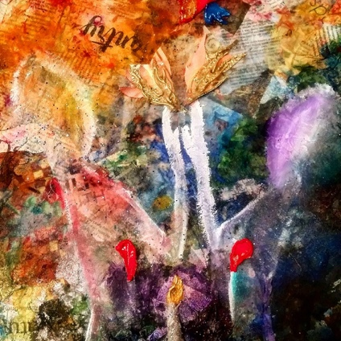
Spirituality-Inspired Art: amyoes.com/galleries
Knowing how difficult it was for me to speak of my own abuse (especially after waking up from a coma months later), I devised a program that combines Broadway theatre with sexual assault awareness and mental health advocacy, in order to empower survivors of assault and to create a more compassionate, open community. I deliver this keynote to support groups, centers, colleges and universities, to promote mental health, provide hope, help, and save lives. My program aims to identify the strength and compassion of Judaism as a transformative healing tool for trauma survivors.
My talk can also be divided into three components:
Part 1) A 70-minute one-woman autobiographical musical – Gutless & Grateful – a comedic yet poignant story on how I survived 27 stomach surgeries, organ failure, and sexual abuse. Through interwoven song and dialogue, I share a primal piece of live-storytelling – a powerful message that it’s possible for survivors become empowered by their own identity and secure in their choices.
Part 2) An educational session/speech A compassionate approach to emotional well-being, how to develop a resiliency toolbox, how to cultivate hope, foster understanding, build a supportive community, and be comfortable reaching out to a support system. Individuals will learn tools for coming forward as survivors, as well as visible allies and leaders, guided by Jewish faith, spirituality and principles.
Part 3) A Q&A session to introduce survivors to sexual assault and wellness resources available to them and answer any questions they might have.
The program can also be followed by smaller workshops to continue building confidence and compassion through creative expression.
“Amy Oestreicher did an amazing presentation to a large group of Jewish high school students at a one night a week Hebrew High School meeting at Congregation B’nai Israel in Bridgeport, CT. The course title is Hope and Survival’ and was extremely fitting to her inspiring story. Students felt comfortable enough to reach out to her after her talk, and she was a tremendous support and much-needed lift. “
-Carole Rubin, Professor at Mercaz Hebrew High School, Bridgeport, CT

Performances for Judaism and Faith

Gutless & Grateful: One Woman Musical:
One bad stomach ache after noshing on a little too much matzah at Passover Dinner changed the course of my life forever. I was your average teenage musical theatre ham, when, two weeks before my senior prom, a blood clot caused my stomach to explode, literally hitting the ceiling of the operating room. After both lungs collapsed, I almost died. When I woke from a coma, months later, doctors told me I had no stomach anymore, I couldn’t eat or drink, and they didn’t know if I’d ever be able to again. Just when you think this is going to be a why me tragedy, I share the secret thriving through 27 surgeries and 6 of the past 10 years unable to eat a morsel of food or drink a drop of liquid: humor! (All in a 70 minute musical comedy!)
Learn more at amyoes.com/GUTLESS.

Original Jewish Full Length Drama: IMPRINTS
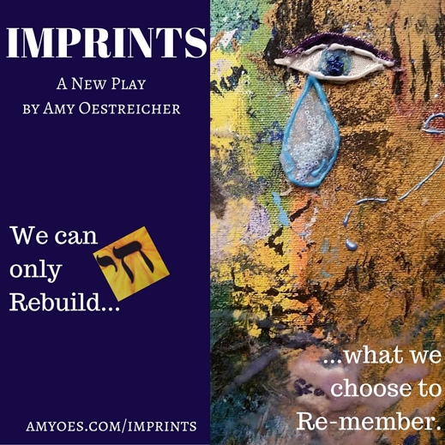
Because I fell into a coma the night my family’s Passover Seder, this holiday has always symbolized redemption and liberation as I healed through a decade of trauma. As I endured six years unable to eat or drink a drop of fluid, the phrase, “Next Year in Jerusalem” took on an entirely new meaning, while my family waited eagerly to celebrate holidays with food and health once again. This was the inspiration behind my original drama, Imprints. The script is loosely based off of a journal my brother kept for the first 72 days I was in a coma, packed with moments of raw emotion as well as endearing humor from a Jewish family who camped out in the ICU together for over a year. Learn more at www.amyoes.com/IMPRINTS

