**Amy Oestreicher**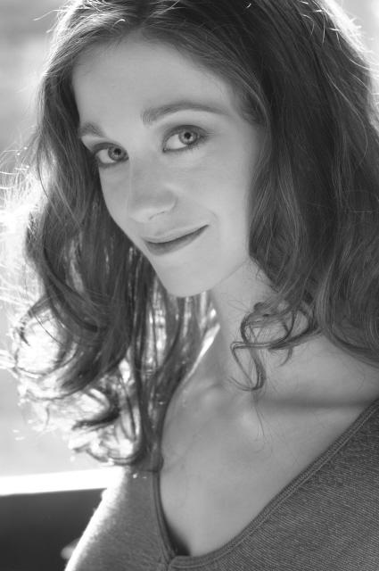

www.amyoes,com

Back to [**Spirituality and Faith Workshops and Performances**](https://amyoes.com/faith/) at [www.amyoes.com/faith](http://www.amyoes.com/faith) for more.

See my articles for [The Jewish Times of Israel](http://blogs.timesofisrael.com/author/amy-oestreicher/)

See my articles for *[The Wisdom Daily](http://thewisdomdaily.com/author/amyoestreicher/)*

# **Other Jewish Articles:**

* **Think You’ll Never Trust Again?***(for Huffington Post)* <http://www.huffingtonpost.com/amy-oestreicher/think-youll-never-trust-a_b_12679990.html>
* **Finding Faith in the ICU:***(For On Being with Krista Tippet)* <https://amyoes.com/2015/08/16/on-being-losing-faith-and-finding-it-again-in-the-icu/>
* My Gra**ndmother’s Heroic Immigration Story:***(for GLAMOUR Magazine)* <http://www.glamour.com/story/immigrant-families-ellis-island>
* **Lost Music Discovered from the Holocaust:***(for HowStuffWorks)* <http://now.howstuffworks.com/2017/03/29/lost-holocaust-survivor-songs-voice-recordings-discovered>

## **Blog Posts**

* **Yom Kippur and [Forgiveness](https://amyoes.com/2016/10/11/yom-kippur/)**
* [Yom Hashoah](https://amyoes.com/2015/04/17/home-is-where-heart-is-studios-where/) Blog post
* [Women of Faith interview](https://amyoes.com/2015/05/05/women-of-faith/)

## **Art, Performance, Speaking**

See my TEDx Talk: [www.amyoes.com/tedx](http://www.amyoes.com/tedx)

Presentation [Hope Builds Resilience at Jewish Orthodox Feminist Alliance Conference](https://amyoes.com/2017/01/16/jofa-2/)

Artist in Residence at [Art Kibbutz, NY](https://amyoes.com/2016/08/25/trust-art/)

**After trauma, faith, joy and gratitude enabled me to survive and thrive.**  This message is imperative to Judaism, and also universally relevant. I hope that sharing my story and will inspire the greater arts community as well. I have used my art to heal myself and found that it has been the best inspiration and therapy in order not just to survive, but thrive. My detours have shown me that I can still be the performer I’ve always aspired to, but now with an even greater gift – a story to tell. Jewish culture is so much based on storytelling, with lessons and morals interwoven, and our stories have a place among them.

**Playing the role of Anne:**

I first read ***The Diary of Anne Frank***in middle school, and was struck by her spirit, and how closely her mindset and vivacity resembled mine. I too would journal like crazy about the beauty of nature and the hidden blessings in life – I shared her infectious childlike wonder and a burgeoning curiosity. I’d read her journal repeatedly be awed by her appreciation of life, faith, hope, belief. I played Anne in two regional productions, and they were the most rewarding theatrical experiences of my life. I truly felt alive in this role, and grounded in my heritage and my endless love for life. Having survived a coma and other medical traumas, it was my artistic fighting spirit and my love of life – like Anne’s – that inspired me to persevere – my writing, art and music got me through. I am also passionate about Jewish music – I’ve learned cantorial chants, and played violin in a Klezmer band. I live life joyously, and my art reflects the grateful, exuberant reverence of God.

## **FIBERS: A Solo Performance**

[FIBERS i](http://amyoes.com/fibers)s a solo docudrama exploring the relationship between history and memory, and the role of storytelling in preserving a legacy. The solo performance is based on over 300 pages of oral history interviews I've conducted and transcribed from relatives spanning three generations and seven countries, chronicling my **family's survival through the Holocaust** and journey to America, featuring historical documents, photographs and recordings and photographs.

### **LEFTOVERS: A New Play with Music**

As the granddaughter of holocaust survivors, I believe that their strength and spirit enabled me to survive, inspiring a spirituality-fueled resilience. Because I fell into a coma the night my family's Passover seder, this holiday has always symbolized redemption and liberation as I healed through a decade of trauma. As I endured six years unable to eat or drink a drop of fluid, the phrase, "Next Year in Jerusalem" took on an entirely new meaning, while my family waited eagerly to celebrate holidays with food and health once again. ***Leftovers*** *is* a compelling, humorous and poignant portrayal of how trauma affects the family - also semi-autobiographical. The script is loosely based off of a journal my brother kept for the first 72 days I was in a coma, packed with moments of raw emotion as well as endearing humor from a Jewish family who camped out in the ICU together for over a year.

See Art Gallery at [www.amyoes.com/galleries](http://amyoes.com/galleries) and creative workshops at<https://amyoes.com/creative-workshops/>

**Teaching**

**Hebrew School Teacher/Bar Mitzvah Tutor/Teaching Artist:** Organized trips relevant to subject, special functions and exhibitions. Participated in regular meetings, trainings and workshops. Interacted with other teachers and staff members to enhance effectiveness of program. Promoted creativity, self-expression and ability to generate unique ideas amongst children. Directed school-wide talent show and student-written skits for school assemblies. Regularly attended staff meetings at administrative offices.

Back to [**Spirituality and Faith Workshops and Performances**](https://amyoes.com/faith/)

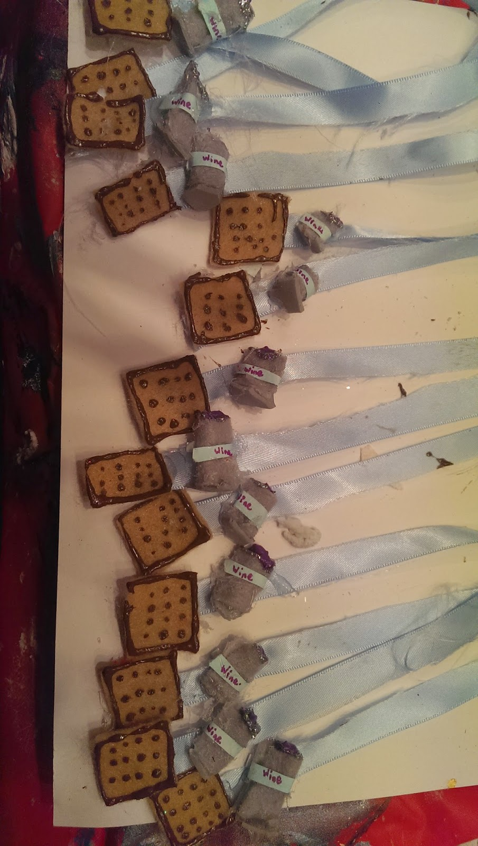

**Amy Oestreicher** is a PTSD peer-to-peer specialist, artist, author, writer for Huffington Post, speaker for TEDx and RAINN, health advocate, survivor, award-winning actress, and playwright, sharing the lessons learned from trauma through her writing, mixed media art, performance and inspirational speaking. As the creator of "Gutless & Grateful," her BroadwayWorld-nominated one-woman autobiographical musical, she's toured theatres nationwide, along with a program combining mental health advocacy, sexual assault awareness and Broadway Theatre for college campuses and international conferences. She has studied as a playwright and performance artist in the National Musical Theatre Institute at the world-renowned Eugene O'Neill Theater Center. Her original, full-length drama, Imprints, premiered at the NYC Producer's Club in May 2016, exploring how trauma affects the family as well as the individual. To celebrate her own “beautiful detour”, Amy created the #LoveMyDetour campaign, to help others cope in the face of unexpected events. "Detourism" is also the subject of her TEDx and upcoming book, My Beautiful Detour, available December 2017. As Eastern Regional Recipient of Convatec’s Great Comebacks Award, she's spoken to hundreds of healthcare professionals at national WOCN conferences, and her presentations on diversity, leadership and trauma have been featured at National Mental Health America Conference, New England Educational Opportunity Association's 40 Anniversary Conference, and have been keynotes at the Pacific Rim Conference of Diversity and Disability in Hawaii, the Eating Recovery Foundation First Annual Benefit in Colorado. She's contributed to over 70 notable online and print publications, and her story has appeared on NBC's TODAY, CBS, Cosmopolitan, among others. Learn more: [amyoes.com](http://amyoes.com/).